*Florida International University*

*School of Computing and Information Sciences*

CEN 5011 Advanced Software Engineering

Final Deliverable

Project Title: SkillCourt 6.0

**Team Members:**

April Perry

Pedro Carrillo

Jofran Duran

Rolando Ramos

**Product Owner(s)**:

Gudmundur Orn Traustason

**Mentor(s)**:

Mohsen Taheri

**Instructor**: Masoud Sadjadi

The MIT License (MIT)

Copyright (c) *2016 Florida International University*

Permission is hereby granted, free of charge, to any person obtaining a copy of this software and associated documentation files (the "Software"), to deal in the Software without restriction, including without limitation the rights to use, copy, modify, merge, publish, distribute, sublicense, and/or sell copies of the Software, and to permit persons to whom the Software is furnished to do so, subject to the following conditions:

The above copyright notice and this permission notice shall be included in all copies or substantial portions of the Software.

THE SOFTWARE IS PROVIDED "AS IS", WITHOUT WARRANTY OF ANY KIND, EXPRESS OR IMPLIED, INCLUDING BUT NOT LIMITED TO THE WARRANTIES OF MERCHANTABILITY, FITNESS FOR A PARTICULAR PURPOSE AND NONINFRINGEMENT. IN NO EVENT SHALL THE AUTHORS OR COPYRIGHT HOLDERS BE LIABLE FOR ANY CLAIM, DAMAGES OR OTHER LIABILITY, WHETHER IN AN ACTION OF CONTRACT, TORT OR OTHERWISE, ARISING FROM, OUT OF OR IN CONNECTION WITH THE SOFTWARE OR THE USE OR OTHER DEALINGS IN THE SOFTWARE.

***Abstract***

*Analytics is completely changing the way sports are being played in this modern era. SkillCourt is another tool that provides a coach or player more information on performance and progression. This document outlines the process of building such a tool and its functional and non-functional requirements specified by the product owner and exemplifies the link between hardware and software.*

**Table of Contents**

**Introduction** ……………………………………………………………………………………………………………………………….. 5

Current System ………………………………………………………………………………………………………………………... 5

Purpose of New System ……………………………………………………………………………………………………………... 5

**User Stories**

Implemented User Stories ………………………………………………………………………………………………………….. 7

Pending User Stories …………………………………………………………………………………………………………..….. 10

**Project Plan**

Hardware and Software Resources ………………………………………………………………………………………….… 12

Sprints Plan …………………………………………………………………………………………………………………………. 13

*Sprint 1*  …………………………………………………………………………………………………………………………... 13

*Sprint 2*  …………………………………………………………………………………………………………………………... 13

*Sprint 3*  …………………………………………………………………………………………………………………………... 14

*Sprint 4*  …………………………………………………………………………………………………………………………... 15

*Sprint 5*  …………………………………………………………………………………………………………………………... 16

**System Design**

Architectural Patterns ………………………………………………………………………………………………………….. 20

System and Subsystem Decomposition ……………………………………………………………………………………….… 21

Deployment Diagram ………………………………………………………………………………………………………….…... 22

Design Patterns ……………………………………………………………………………………………………………….….... 22

**System Validation**  …………………………………………………………………………………………………………………….23

**Glossary**  ………………………………………………………………………………………………………………………………….37

**Appendix**  ………………………………………………………………………………………………………………………………….38

Appendix A - UML Diagrams ……………………………………………………………………………………………………. 38

*Static UML Diagrams*  ……………………………………………………………………………………………………….38

*Dynamic UML Diagrams*  …………………………………………………………………………………………………..40

Appendix B - User Interface Design ……………………………………………………………………………………….…... 52

Appendix C - Sprint Review Reports ……………………………………………………………………………………...…… 69

Appendix D - Sprint Retrospective Reports …………………………………………………………………….…………… 74

**References** ……………………………………………………………………………………………………………………...………...80

# Introduction

SkillCourt 6.0 is the most current version of the program and has been completely rebuilt and redesigned from the ground up as an Android Application. The change from the current Java run, wired, computer program to a wireless mobile application comes as not only a request from the product owner but as a way to make the product more appealing to the public and more accessible and easy to use with even more advanced options and customization.

## Current System

SkillCourt 5.0 is the most current version of the program and has been completely rebuilt and redesigned from the ground up. A completely new pad design has been constructed and the programming language has been changed from Processing to Java. The reason for the language change is to have more functionality through the availability of more libraries, an extensible and easy to understand program and finally, to have an ide independent system as Processing also requires the use of the Processing IDE which isn’t as supported as before.

All previous versions of SkillCourt and the current version use the Arduino Microcontroller and communicate via the system's serial port. There is a dependency relationship in the previous versions of SkillCourt as a Master/Slave relationship was implemented so the pads needs to be aware of the existence of all other pads. This is no longer the case as each Arduino and pad is its own entity which also does not restrict the performance as it is now more scalable plus the introduction of wireless capability this semester!

## Purpose of New System

SkillCourt 6.0 is the most current version of the program and has been completely rebuilt and redesigned from the ground up as an Android Application. The change from the current Java run, wired, computer program to a wireless mobile application comes as not only a request from the product owner but as a way to make the product more appealing to the public and more accessible and easy to use with even more advanced options and customization.

The use of wireless connecting to the arduinos from a mobile phone/tablet is the biggest feature of this semester final product. Being able to play a game from such device gives SkillCourt an exponential leg up on the limit functionality of SkillCourt 5.0. Not only have we designed this new application to play a game, there are many options within the application that allow for complete customization of game sequences, the option for a user to be a coach and hold a team, and the ability for players and coaches to view the statistics and progress of themselves and their players! All of these things done within this semester are a big step forward for not only making the product more marketable to improve players soccer skills, but also will be a valuable tool for coaches now, alike.

# User Stories

The following section provides the detailed user stories that were implemented in this iteration of SkillCourt. These user stories served as the basis for the implementation of the project redesign and the new features. This section also shows the user stories that are to be considered for future development.

## Implemented User Stories…

**User Story #912 “Move Sequences to Create Game Page”**

As a PLAYER, I want the ability to see the sequences in a drop down in the create game page and select a default one before starting a game, so I can test my abilities using that specific sequence.

**Acceptance Criteria**

1. User must be logged in
2. User must have at least one sequence saved
3. The selected sequence will be saved on the database as the default one.

**\*\*\*\*\*\***

**User Story #897 -- “Refactor statistics page CODE”**

As a DEVELOPER, I would like to refactor the current statistics page’s code in order to comply with the new format of the Database introduced this Sprint, as well as integrate into the new dashboard layout, so that the statistics page can be accessed via the new dashboard and still display data as expected.

**Acceptance Criteria:**

1. New dashboard is ready

2. New database layout can be queried

**\*\*\*\*\*\***

**User Story #896 -- “Pull live STATS from database to populate graphs”**

As a PLAYER, (now that the graphs aesthetics are coded for) I would like to be able to view my LIVE statistics that I have stored in the database, so that I know the graphs that I am viewing on the statistics page are accurate in relation to my individual progress.

**Acceptance Criteria:**

1. Graphs are empty and ready to be populated
2. Firebase query returns data
3. The data returned is in the expected format

**\*\*\*\*\*\***

**User Story #892** - **“Show Dashboard”**

As a player I would like to see the games played this week and my history of all games played. Also, I would like an easy navigation view to go through the application

**Acceptance Criteria**

1. Can start a game with a single button from anywhere in the application
2. Can navigate to all the features of skill court

**\*\*\*\*\*\***

**USER STORY​** #887 - **“Start a game in Beat Timer mode”**

As a user I would like to start a game using the beat timer game mode which will allow me to test my reactions during a customizable window of seconds

**Acceptance Criteria**

1. Seconds should be customizable (S)
2. The pads change color each S seconds
3. I can see my score at the end of the game

**\*\*\*\*\*\***

**User Story #883 Show/select sequences in drop down before starting a game.**

As a PLAYER, I want the ability to see the sequences in a drop down and select a default one before starting a game, so I can test my abilities using that specific sequence.

**Acceptance Criteria**

1. User must be logged in
2. User must have at least one sequence saved
3. The selected sequence will be saved on the database as the default one.

**\*\*\*\*\*\***

**User Story #872 -- “View graphical representation of STATISTICS”**

As a PLAYER, I would like the ability to see the graphical statistics of games that I have played, so that I can easily visualize my progress and easily track trends and/or patterns in my play.

**Acceptance Criteria:**

1. User must be logged in

2. User must have played a game

3. User must have saved data from game

**User Story #864 – “Enroll as a coach”**

As a player I would like to enroll as a coach so that I can have teams which I can assign training sessions and follow their progress

**Acceptance Criteria**

1. User get access to the Coach dashboard

**\*\*\*\*\*\***

**User Story #869 “Set number of steps in a sequence”**

As a PLAYER, I want to be able to set/select the number of steps that a game sequence will have, so I can test my players in specific areas and on specific skills

**Acceptance Criteria**

1. Sequence configuration button will be available
2. A Number picker will show where you can select a number to define how many steps the game sequence will have
3. Steps sequence page will show number of steps selected before.

**\*\*\*\*\*\***

**User Story #835- See history of games played by players in my teams**

As a coach I would like to see the history of the players I’ve added to my team so that I can follow their progress and make suggestions regarding their training.

**Acceptance Criteria**

1. The coach is able to see the history of games played of a player he/she had previously added to one of his/her teams chart with my games played last week and the history of all my games easily

**\*\*\*\*\*\***

**User Story #831 - Search users and add them to teams**

As a coach I would like to search for user already registered in the app so that I can follow their trainings.

**Acceptance Criteria**

1. The app shows a search box where the coach can type an user’s email.
2. If found the app will ask if the coach wants to add the user found to one of his teams.
3. Once added to one his teams, the coach can see this user’s history and statistics.

**\*\*\*\*\*\***

**User Story #830** - **View and add teams**

As a coach I would like to be able to create teams within my profile and see them listed so that I can follow the progress of the players I’ve added to those teams.

**Acceptance Criteria**

1. User with the role of coach is able to access a screen that allows him to see a list of the teams he has created and a visual element to create a new team that would be added to the list.
2. The app validates that the team has a different name from previous teams created by same user.
3. After creating teams, the teams maintain in the user profile when the user logs out and logs in again, the coach would be able to see all the teams he has created as a list.

**\*\*\*\*\*\***

**USER STORY​** #825 - **“App - History Page option”**

As a PLAYER, I want to have an option on the main dashboard to view a separate page devoted to my History, so that I can review such statistics.

**Acceptance Criteria**

1. Player is logged in
2. Player has completed games
3. Player has saved results

**\*\*\*\*\*\***

**USER STORY #803​** - **“Start a game”**

As a PLAYER I would like to start a game from my android phone to start practicing my skills on SkillCourt

**Acceptance Criteria**

1. Game configurations should be possible (time, game mode, number of pads)
2. A timer with the time left displayed should be send after i start a game until game ends
3. I can see my current score during the game

**\*\*\*\*\*\***

**USER STORY​ #785-​ “Android App –Maintain Session”**

As a PLAYER, I want to be able to maintain my session within the Android app, so that I do not have to go thru the login process every time I exit and enter the application on my phone.

**Acceptance Criteria**

1. Player is successfully logged into the system
2. Exits app without logging out
3. Re-enters with same phone

**\*\*\*\*\*\***

**USER STORY #784​– “Android App - Registration”**

As a PLAYER, I want to register myself as a user in the Android app, so that I utilize all of the feature of the SkillCourt App

**Acceptance Criteria**

1. Must enter appropriate information in all required fields
2. Must press submit
3. Connection to Firebase must be able to be accessed and saved to

**\*\*\*\*\*\***

**USER STORY ​#783 “Android App - Login”**

As a PLAYER, I want to register myself as a user in the Android app, so that I utilize all of the feature of the SkillCourt App

**Acceptance Criteria**

1. Must enter appropriate information in all required fields
2. Must press submit
3. Connection to Firebase must be able to be accessed and saved to

**\*\*\*\*\*\***

**USER STORY​ #788​ “Create Steps Sequence”**

As a PLAYER, I want to be able to create/define a game myself (a sequence of different pads), so I can test my players in specific areas and on specific skills

Acceptance Criteria

1. Steps configuration button will be available
2. You can select up to 5 steps where you will select the order how the pads will be light up
3. The sequence will be saved on the database.

## Pending User Stories

1. Assign Routine to Team (#834)
2. Assign Routine to Players (#833)
3. Register and add players to team (#832)

# Project Plan

This section describes the planning that went into the realization of this project. This project incorporated the agile development techniques and as such required the sprints to be planned. These sprint plannings are detailed in the section. This section also describes the components, both software and hardware, chosen for this project.

## Hardware and Software Resources

The following is a list of all hardware and software resources that were used in this project:

**Arduino**

Arduino is a hardware and software company, project, and user community that designs and manufactures computer open-source hardware, open-source software, and microcontroller-based kits for building digital devices and interactive objects that can sense and control physical devices.

**AdaFruit LED strips**

A series of LED strips are used which lights up the pad a specific color. Each LED strip is fitted with 120 LED lights and is roughly 4 feet long

**FlexiForce Force Sensor**

A force sensor is attached to the center of each pad which current detects whether or not a pad has been it. In the future, the sensor will have the ability to detect the exact amount of force exerted and the velocity in which the ball traveled.

**Sanwa Push Buttons**

A push button that is attached to the pad which detects when a soccer ball has hit the pad. We decided to switch from Force Sensor as we were having some trouble with the hardware. It returns 1023 when you push it and 0 otherwise.

**Java**

Java is the core language used in Android source code.

**XML**

XML is the supplementary language used in Android coding to take care of layout/front end displays

**C**

The Arduino MicroController runs completely on C with it’s own Serial port package, SPI.h and LED adjuster FastLed.h

**Mingle**

Mingle was used as a planning and management tool for the various agile development processes.

**Firebase**

Chosen as the non-relational cloud database because of the open source nature and ease of integration with android coding

**Github**

Github was used to store and manage the source code.

**Slack**

Main space for team communication and collaboration.

**Gmail**

Gmail was used for communication.

**Google Drive**

Google Drive was used to store project documents and to transfer data between the group members.

**Sprints Plan**

**Sprint #1**

The product owner chose the following user stories to be done during the next sprint. They are ordered based on their priority.

* User Story #780 (in mingle) - Version 5.0 code review
* User Story #781 (in mingle) - Successfully run SkillCourt 5.0
* User Story #782 (in mingle) - Android, Arduino, Java refresh and research!

The team members indicated their willingness to work on the following user stories.

* Names of participants willing to work.
* User Story #780 - ALL DEVELOPERS
* User Story #781 - ALL DEVELOPERS
* User Story #782 - ALL DEVELOPERS

-------------------------------------------------------------------------------------------------------------------------

**Sprint #2**

The product owner chose the following user stories to be done during the next sprint. They are ordered based on their priority.

* User Story #783 - User Login
* User Story #784 - User Registration
* User Story #785 - Maintain Session
* User Story #800 - Game < 60 seconds
* User Story #802 - Game mode beat timer

The team members indicated their willingness to work on the following user stories.

* Names of participants willing to work.
* User Story #783 - Pedro
* User Story #784 - Pedro
* User Story #785 – Pedro/April
* User Story #800 – Pedro/April
* User Story #802 – Pedro/April

**Sprint #3**

The product owner chose the following user stories to be done during the next sprint. They are ordered based on their priority.

* User Story #788 - User generated game sequence
* User Story #825 - History Page
* User Story #803 - Start game from android application
* User Story #864  - Enroll as a Coach
* User Story #830 - Create Teams

The team members indicated their willingness to work on the following user stories.

* Names of participants willing to work.
* User Story #788 - Rolando
* User Story #803 - Pedro Carrillo
* User Story #825 - April Perry
* User Story #830 - Jofran
* User Story #864 - Jofran

-------------------------------------------------------------------------------------------------------------------------

**Sprint #4**

The product owner chose the following user stories to be done during the next sprint. They are ordered based on their priority.

* User Story #831 - Search and Add Users
* User Story #872 - View history graphically
* User Story #869 - Set # of sequences
* User Story #803 - Start a game

The team members indicated their willingness to work on the following user stories.

* Names of participants willing to work.
* User Story #831 - Jofran
* User Story #872- April
* User Story #803 - Pedro
* User Story #869 - Rolando

---------------------------------------------------------------------------------------------------------------------------

**Sprint #5**

The product owner chose the following user stories to be done during the next sprint. They are ordered based on their priority.

* User Story #831 - Search and Add Users
* User Story #896 - View LIVE/REAL data from database on graphs
* User Story #887 - Start a game/Beat timer Mode
* User Story #883 – Show Sequences in drop down menu

The team members indicated their willingness to work on the following user stories.

* Names of participants willing to work.
* User Story #831 - Jofran
* User Story #887 - Pedro
* User Story #896 – April
* User Story #883 - Rolando

---------------------------------------------------------------------------------------------------------------------------

**Sprint #6**

The product owner chose the following user stories to be done during the next sprint. They are ordered based on their priority.

* User Story #835 - View history of players in my teams
* User Story #892 - Show dashboard
* User Story #896 – Refactor Stats Code
* User Story #912 – Move Sequences to Create Game Page

The team members indicated their willingness to work on the following user stories.

* Names of participants willing to work.
* User Story #835 - Jofran
* User Story #892 – Pedro
  + User Story #896 – April
  + User Story #912 – Rolando

**Sprint #7**

The product owner chose the following user stories to be done during the next sprint. They are ordered based on their priority.

* Next SPRINT is for merging code and DOCUMENTATION AND POSTERS!

The team members indicated their willingness to work on the following user stories.

* Names of participants willing to work.
* Next SPRINT is for merging code and DOCUMENTATION AND POSTERS!

# System Design

SkillCourt is heavily influenced by the hardware as well as the needs of the modern day soccer player and coach. With a series of fast, high interval training sessions, the devices must run fast and accurate and the code must be efficient so not to affect performance and scalability. SkillCourt is divided into different sub-systems. Modularly developed to allow the re-use and preprogramming of needed details in later development.

## Architectural Patterns

The main architectural pattern used for this project is Model View Controller (MVC) and Layered design approach. This involved the user interacting with a start menu which sets all the necessary initial variable and also physical interaction with the pad which is layered in its approach from recording the hit to transmitting the data to and from the systems

For the game implementation, we decided to implement an MVP (Model-View-Presenter) architecture which allows us to separate the business logic from our views improving our code readability and design. This allowed us to handle arduinos in multiple threads and the timer without having to worry about lifecycle methods you can see in an android activity/fragment.x

## System and Subsystem Decomposition

There are three systems at work, each divided further into their own subsystems. The three main systems are the Microcontroller, the Android controller and the Firebase Database.

The Arduino microcontroller is subdivided into a section that handles the communication of the pads to and from the system, a section in charge of regulating the LEDs and a section that records the readings from the force sensors. At the moment, the communication is handled exclusively through the use of serial ports. Next, the LEDs are controlled by methods that send readings to the individual pins on the boards that correspond to the instructions received from the Java controller. Finally, the force sensor is controlled by methods that record the various voltages received by each pin on the arduino and this information is reported back to the Java controller to be stored.

The Android controller is divided into different subclasses and pages, each handling a specific aspect of the program in a highly cohesive manner. Not only is this where the user interacts with the app, but from here the wireless control of the lights and feedback from the sensors are all handled.

The final system is the Model, it is in charge of all communication to and from the database. At A, the database is in the cloud (FIREBASE). All data is stored in a non relational manner.

Subsystems.png

## Deployment Diagram

Deployment Diagram

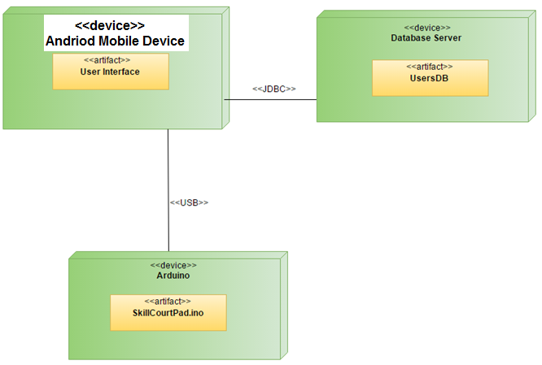

## Design Patterns

The design pattern used in the system is the Adapter pattern.

Singleton pattern for Arduino Manager and Game.

# System Validation

In this section, all of the test cases that were down to validate our system are outlined. All of the testing was done manually, following the input requirements of the test case

# Use Case #912

**Test Case 1**

○ Purpose: Test that the newly sequences dropdown shows/populate in the Create Game page

○ Precondition: User is logged in and see the sequences dropdown on Create Game page

○ Expected Result: The new sequences dropdown shows and is populated by users’ sequences.

○ Actual Result: Same as expected.

○ Status: PASS

**Test Case 2**

○ Purpose: Test selecting/saving default sequence from dropdown

○ Precondition: User is already inside the Create Game page

○ Expected Result: User selects a sequence from dropdown and is set to default in database

○ Actual Result: Same as expected.

○ Status: PASS

# Use Case #897

**Test Case 1**

○       *Purpose:*             RE-Test the accuracy of the database retrieval for a player  
                                      that has saved game data

○       *Precondition:*      View Statistics page

○       *Expected Result:* The graphs are still created with the correct data

○       *Actual Result:*     Same as expected.

○   *Status:* **PASS**

**Test Case 2**

○       *Purpose:*             Test the functionality of the new dashboard’s ‘Statistics’  
                           menu button

○       *Precondition:*      Click on ‘Statistics’ text in new side-view menu.

○       *Expected Result:* The stats page is displayed

○       *Actual Result:*     Same as expected.

○   *Status:* **PASS**

# Use Case #896

**Test Case 1**

○       *Purpose:*             Test the functionality of the page if the player has not  
                                      played any games/saved any results

○       *Precondition:*      Player that has not played any games/saved any game data clicks the “View History” button on the main dashboard

○       *Expected Result:* The graphs are created but with no lines/bars/counts. A  
                           message with display within them saying no data found

○       *Actual Result:*     Same as expected.

○   *Status:* **PASS**

# Use Case #892

Test Case 1

○   **Purpose:** Test the navigation

○   **Precondition:**  User is already logged in and there is arduinos connected

○   **Expected Result:** Navigate through the app using the tabs

○   **Actual Result:**I could navigate through the app using the tabs

○   **Status: PASSED**

Test Case 2

○  **Purpose:** Games played last week can be seen in a chart

○  **Precondition:** User is already logged in and there is arduinos connected

○  **Expected Result:** User can see his accuracy in the past week games

○  **Actual Result:**User can see his accuracy in the past week games

○   **Status: PASSED**

Test Case 3

○       **Purpose:**    User can see his game history

○       **Precondition:** User is already logged in and there is arduinos connected

○       **Expected Result:** User can see a list of his game history

○       **Actual Result:**User can see a list of his game history

○       **Status: PASSED**

# Use Case #887

Test Case 1

○       **Purpose:**   Test the beat timer mode

○       **Precondition:** User is already logged in and there is arduinos

○       **Expected Result:** Player can play a game by touching the pressure  
 sensors and the pads will change color each ‘S’ Seconds

○       **Actual Result:**Couldn’t test because problem with hardware

○       **Status: PASSED**

Test Case 2

○       **Purpose:** Can’t set the frequency without setting time first.

○       **Precondition:**User is already logged in and there are ardunios

○       **Expected Result:** User should get a message that they can’t select the  
 frequency time without selecting time first

○       **Actual Result:** User can see a message that tells him what to do firs **Status: PASSED**

# Use Case #883

**Test Case 1**

○       *Purpose:*             Test that the newly sequences dropdown shows in the Main Dashboard

○       *Precondition:*     User is logged in and see the sequences dropdown on Main page

○       *Expected Result*: The new sequences dropdown shows and is populated by users’ sequences.

○       *Actual Result:*     Same as expected.

○       *Status:* **PASS**

**Test Case 2**

○       *Purpose:*             Test selecting/saving default sequence from dropdown

○       *Precondition:*      User is already inside the Main Dashboard page

○       *Expected Result:* User selects a sequence from dropdown and is set to default in Firebase database

○       *Actual Result:*     Same as expected.

○   *Status:* **PASS**

# Use Case #872

**Test Case 1**

○       *Purpose:*              Test that the newly formatted “History” page is  
                                       clickable via the Main Dashboard

○       *Precondition:*       User is logged in and clicks “History” button on  
                                                   Main Dashboard page

○       *Expected Result:* The new general “History” page pops up and the  
                                                  graph is created.

○       *Actual Result:*      Same as expected.

○       *Status:* **PASS**

**Test Case 2**

○       *Purpose:*             Test the scroll ability of the page

○       *Precondition:*      User is already inside the “History” page and

                                       scrolls down

○       *Expected Result:*  The new general “History” page pops up and the  
                                                   graph is created.

○       *Actual Result:*       Same as expected.  
 *Status:* **PASS**

# Use Case #835

**Test Case 1**

* *Purpose:* Test that when a coach intends to view the history of a player that is part of the roster of one of his/her teams, the information is accurately retrieved from the database
* *Precondition:* User is logged in and, has selected one of the team he created beforehand and added players as well.
* *Expected Result:* When a player is selected the history of games of that player are shown.
* *Actual Result:* Same as expected
* *Status:* PASS

# Use Case #831

**Test Case 1**

* *Purpose:* Test that the app shows the user’s information of the player with the email that was entered in the search
* *Precondition:* User is logged in and from the Main Coach Dashboard clicks on the search icon in the upper right corner, enters a player’s email address and clicks on the search icon in the device’s keyboard
* *Expected Result:* The apps retrieves the correct user instance from the database
* *Actual Result:* Same as expected
* *Status:* PASS

**Test Case 2**

* *Purpose:* Test that a user retrieved by a search can be saved to a team
* *Precondition:* User is logged in, have searched for an user and obtained a result.
* *Expected Result:* Once the coach selects the team he was to add the player to, the player shows as part of the roster for that team.
* *Actual Result:* Same as expected

*Status:* PASS

# Use Case #830

**Test Case 1**

* *Purpose:* Test that the Teams View is showing the teams saved in the database
* *Precondition:* User is logged in and from the Main Coach Dashboard clicks on Coaching
* *Expected Result:* When the aforementioned option is clicked the app goes to the Teams View that show a list of all the teams saved on the database.
* *Actual Result:* Same as expected
* *Status:* PASS

**Test Case 2**

* *Purpose:* Test that a new team created is being saved in the database
* *Precondition:* User is logged in and from the Main Coach Dashboard clicks on the plus button located in the bottom right corner, then fills out the form for a new team and clicks on the save button.
* *Expected Result:* Once the save button is clicked, the app returns to the teams list view and shows the new team on the list.
* *Actual Result:* Same as expected
* *Status:* PASS

# Use Case #803

Test Case 1

○    **Purpose:**     Test that I can’t go into Start Game or Create game screen without arduinos connection

○   P**recondition:** User is logged in. No arduino is on.

○   **Expected Result:** The screen should popup a window that says “No connection available”

○       **Actual Result:** Same as expected.

○       **Status: PASS**

Test Case 2

○   **Purpose:** Test the hit mode

○   **Precondition:**User is already logged in and there is arduinos connected

○  **Expected Result:** Player can play a game by touching the sensors

○  **Actual Result:**Same as expected. But the sensors are not consistent.

○  **Status: PASS**

# Glossary

**Arduino:** Arduino is a hardware and software company, project, and user community that designs and manufactures computer open-source hardware, open-source software, and microcontroller-based kits for building digital devices and interactive objects that can sense and control physical devices.

**Force Sensor:** FlexiForce force sensors can measure force between almost any two surfaces and are durable enough to stand up to most environments. Our sensors are available off-the-shelf for prototyping or can be customized to meet the specific needs of your product design and application requirements.

**LED:** is a light-emitting diode (LED) product which is assembled into a lamp (or light bulb) for use in lighting fixtures. LED lamps have a lifespan and electrical efficiency which are several times longer than incandescent lamps, and significantly more efficient than most fluorescent lamps, with some chips able to emit more than 300 lumens per watt.

**Microcontroller:** (or MCU, short for microcontroller unit) is a small computer (SoC) on a single integrated circuit containing a processor core, memory, and programmable input/output peripherals. Program memory in the form of Ferroelectric RAM, NOR flash or OTP ROM is also often included on chip, as well as a typically small amount of RAM. Microcontrollers are designed for embedded applications, in contrast to the microprocessors used in personal computers or other general purpose applications consisting of various discrete chips.

**Processing:** is an open source computer programming language and integrated development environment (IDE) built for the electronic arts, new media art, and visual design communities with the purpose of teaching the fundamentals of computer programming in a visual context, and to serve as the foundation for electronic sketchbooks.

**View Controllers**: view controllers are the classes that interact with the elements on a storyboard.

Appendix

Appendix A - UML Diagrams

### Static UML Diagrams

**Start a game/ Play a game/ All games modes**

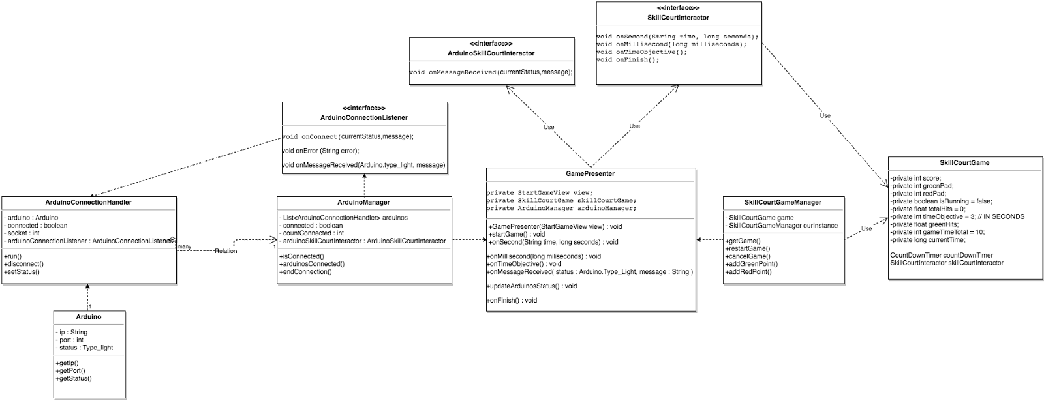https://lh5.googleusercontent.com/aioP7g8sXo5nODTCOBOb_LJh99HSa5VJkyb0siYklVjroVeQSINy8-NanVgGtIOpaTRSRwlt_P_LlgoslHdRFWfKCmAlBGf9jLxzRlLI31b5nPDernOdBtlcZ-duJj2k0A4t0Oxt

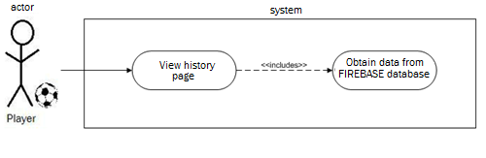

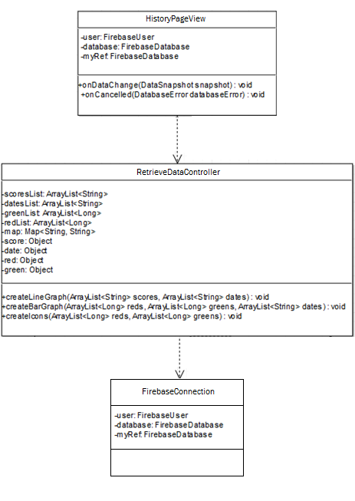**Viewing History**

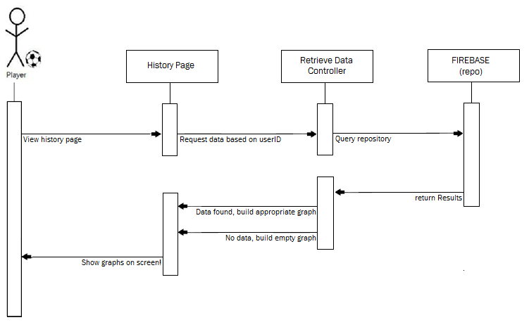

**Untitled Diagram (4).pngCreate Team**

**&**

**Search and add users to Team**

### Untitled Diagram (5).png

Untitled Diagram.pngUntitled Diagram 1.png**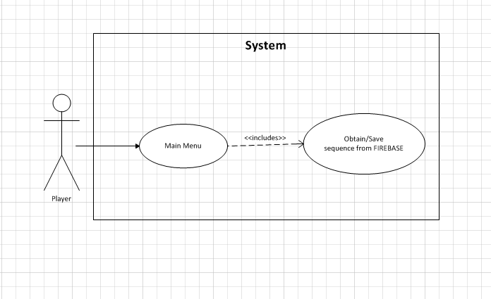Sequences   
Creating/Storing/Searching**

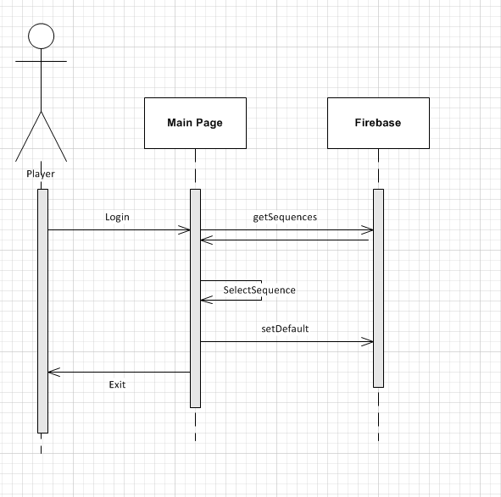

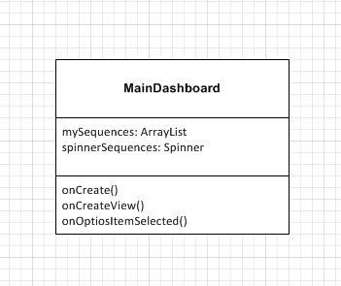

## 

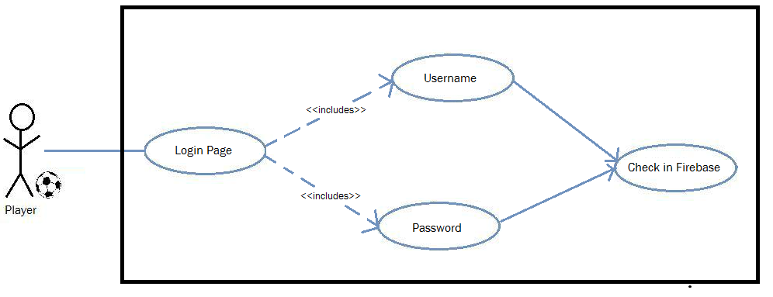

**Login/ Maintain Session**

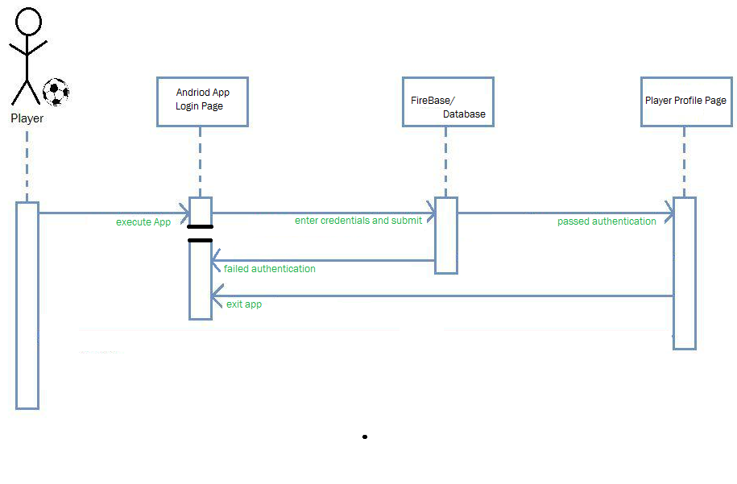

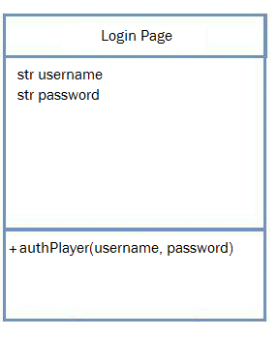

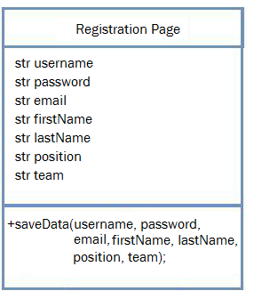**Register as Player/Register as Coach (after player)**

Untitled Diagram.png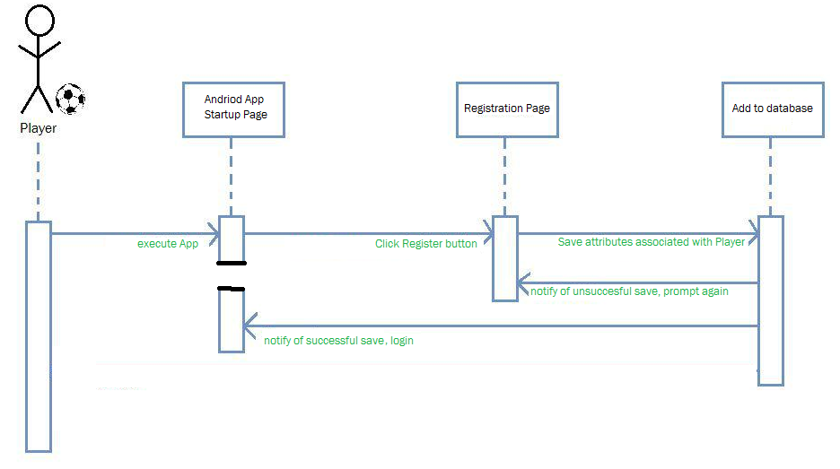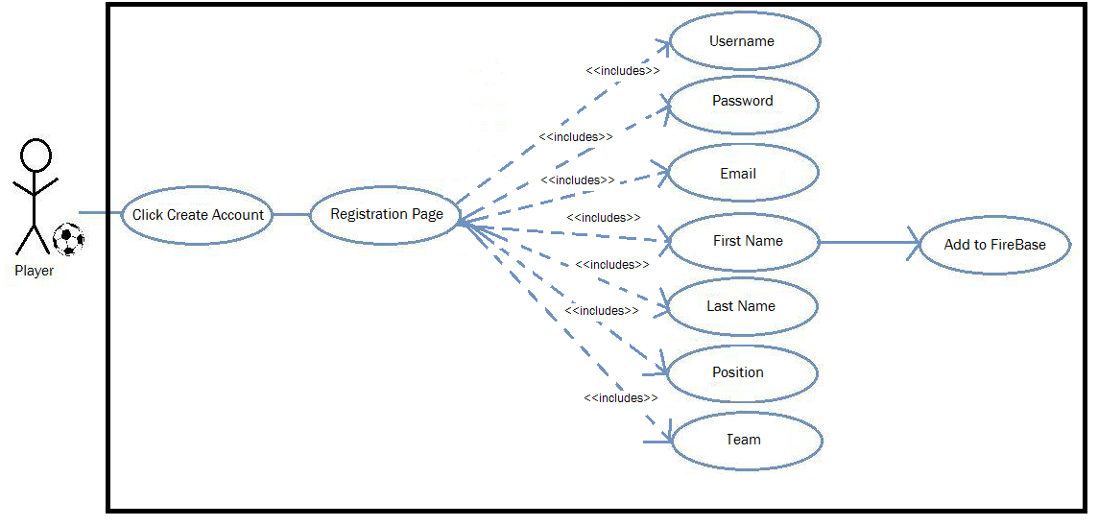

## https://lh5.googleusercontent.com/NGMvLw84jXsoMpBevBlgHWaa3uO0NYK7L3CEJfo7ctFol5iuFNC26SsNsZWqzQ9wCj55h-ip_ReTIGGHxeqvieJmzT7WQbdrxWhF91fgeRhfOH7xyYsYksDh7UBM3cr0Wdbk-07RAppendix B - User Interface Design

## https://lh5.googleusercontent.com/2HgtmanKKjRHnbHfvw_DT5CDv4-em5YWJpYDCKpK-88w_XF2u_uWwHFa7k2hqG6fn40RPh9EQHGVUjdYdiPkj3_zPWxjNQQMplowRc_h0aPqnWJgkdVVdt5pKEXzy6Kz5q0QgoCG

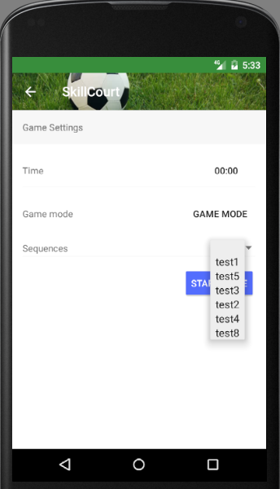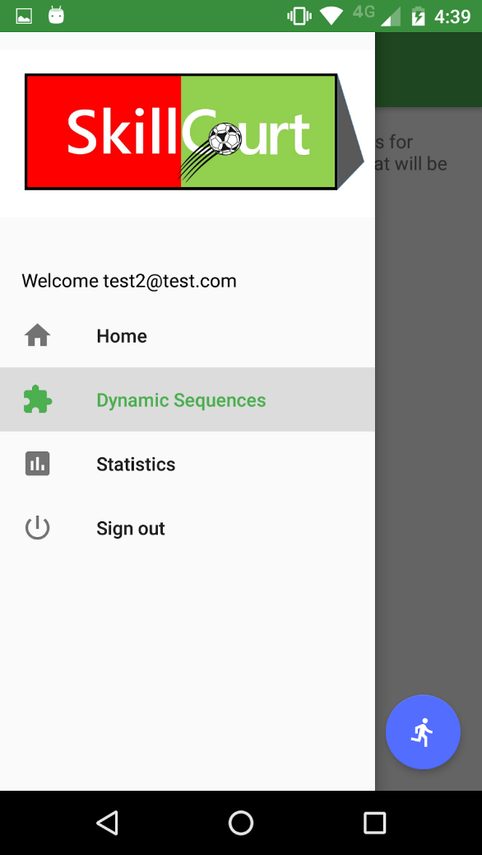

## 

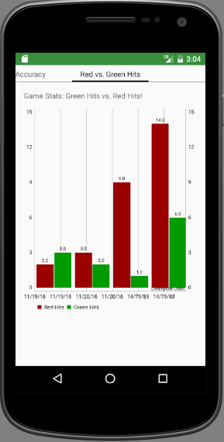

## 

## Appendix C - Sprint Review Reports

**SPRINT #1**

Attendees: Gummi, Gajen, Sean, Manuel, April, Pedro, Rolando, Jofran

Start time: 6:30pm

End time: 7:30pm

After a show and tell presentation, the implementation of the following user stories were accepted by the product owners: All.

* User Story #780 (in mingle) - Version 5.0 code review
* User Story #781 (in mingle) - Successfully run SkillCourt 5.0
* User Story #782 (in mingle) - Andriod, Arduino, Java refresh and research!

The following ones were rejected and moved back to the product backlog to be assigned to a future sprint at a future Spring Planning meeting.

* N/A ! All Good :)

----------------------------------------------------------------------------------------------------------------------------

**SPRINT #2**

Attendees: Gummi, Tony, April, Pedro, Rolando, Jofran, Manuel

Start time: 6:30pm

End time: 7:30pm

After a show and tell presentation, the implementation of the following user stories were accepted by the product owners: All.

* User Story #783 - User Login
* User Story #784 - User Registration
* User Story #785 - Maintain Session
* User Story #800 - Game < 60 seconds
* User Story #802 - Game beat timer mode

The following ones were rejected and moved back to the product backlog to be assigned to a future sprint at a future Spring Planning meeting.

* N/A ! All Good :)

----------------------------------------------------------------------------------------------------------------------------

**SPRINT #3**

Attendees: Gummi, Tony, April, Pedro, Rolando, Jofran, Manuel

Start time: 6:30pm

End time: 7:30pm

After a show and tell presentation, the implementation of the following user stories were accepted by the product owners: All.

* User Story #788 - User generated game sequence
* User Story #825 - History Page
* User Story #803 - Start game from android application
* User Story #864  - Enroll as a coach
* User Story #830 - Create Teams

The following ones were rejected and moved back to the product backlog to be assigned to a future sprint at a future Spring Planning meeting.

* N/A - So far, so good...

----------------------------------------------------------------------------------------------------------------------------

**SPRINT #4**

Attendees: Gummi, Tony, April, Pedro, Rolando, Jofran, Manuel

Start time: 6:30pm

End time: 7:30pm

After a show and tell presentation, the implementation of the following user stories were accepted by the product owners: All.

* User Story #788 - User generated game sequence
* User Story #825 - History Page
* User Story #844 - Detailed History Page
* User Story #803 - Start game from android application
* User Story #864  - Enroll as a coach
* User Story #830 - Create Teams

The following ones were rejected and moved back to the product backlog to be assigned to a future sprint at a future Spring Planning meeting.

* N/A - So far, so good..

----------------------------------------------------------------------------------------------------------------------------

**SPRINT #5**

Attendees: Gummi, Tony, April, Pedro, Rolando, Jofran, Manuel

Start time: 6:30pm

End time: 7:30pm

After a show and tell presentation, the implementation of the following user stories were accepted by the product owners: All.

* User Story #896 - Pull live stats from database
* User Story #803 - Start game from android application
* User Story #864  - Enroll as a coach
* User Story #830 - Create Teams

The following ones were rejected and moved back to the product backlog to be assigned to a future sprint at a future Spring Planning meeting.

* N/A - So far, so good..

----------------------------------------------------------------------------------------------------------------------------

**SPRINT #6**

Attendees: Gummi, Tony, April, Pedro, Rolando, Jofran, Manuel

Start time: 6:30pm

End time: 7:30pm

After a show and tell presentation, the implementation of the following user stories were accepted by the product owners: All.

* User Story #897 - Refactor stats code
* User Story #892 - Show dashboard
* User Story #835 - View history of all my players games

The following ones were rejected and moved back to the product backlog to be assigned to a future sprint at a future Spring Planning meeting.

* N/A - So far, so good..

**References**

<https://www.arduino.cc/>